2015 Build Agent Setup

# Prerequisites

The following software should be installed before the Build Server is made available to the development teams.

Required Software:

* Visual Studio 2015 Professional
* .Net Framework 4.6
* Powershell 5
* TFS 2010 Obj Model
* MSBuild 2013
* ServiceBus 1.1
* Wix 3.8
* ASP .NET MVC 4.0

On the D: Drive create a new folder at the root level called **B**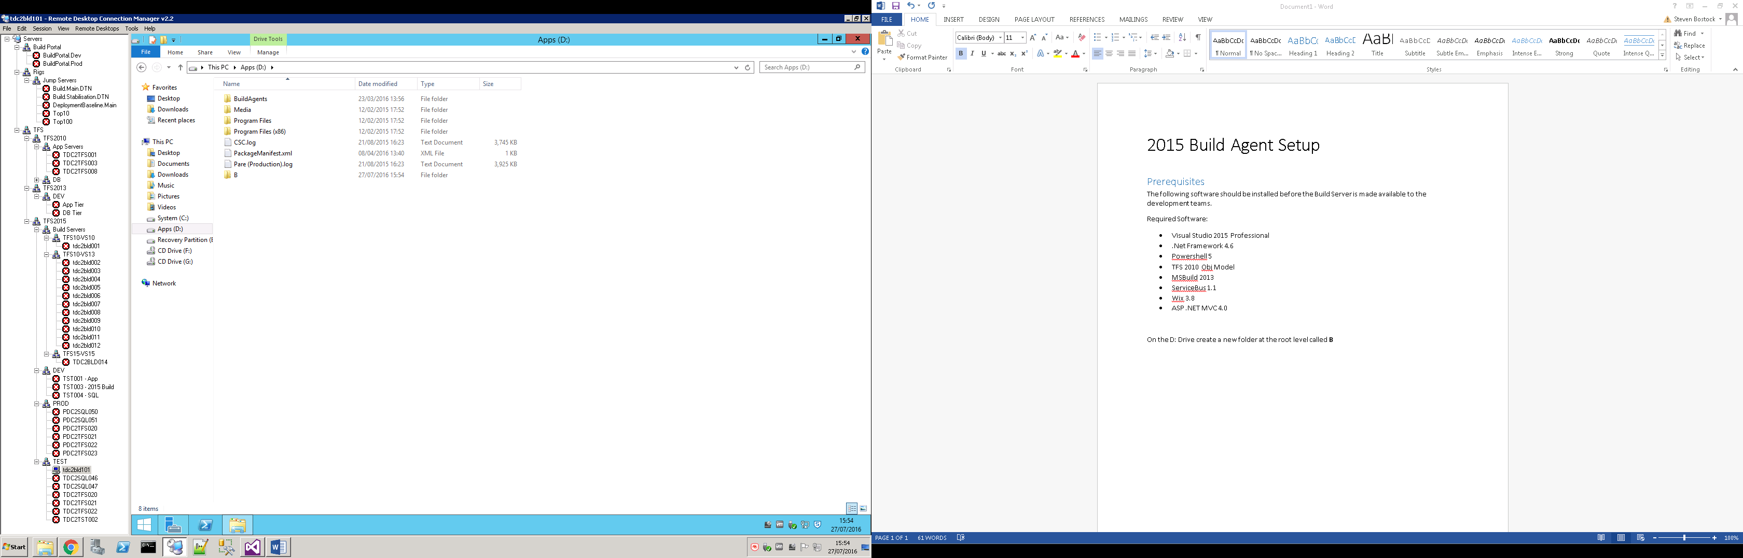

# Getting the Agent Software from TFS

To get the Agent Software, navigate to the following url: [http://***TFSServerName***:***TFSPort***/***CollectionName***/_admin](http://TFSServerName:TFSPort/CollectionName/_admin)

Then click on the Agent Queues tab as shown below  
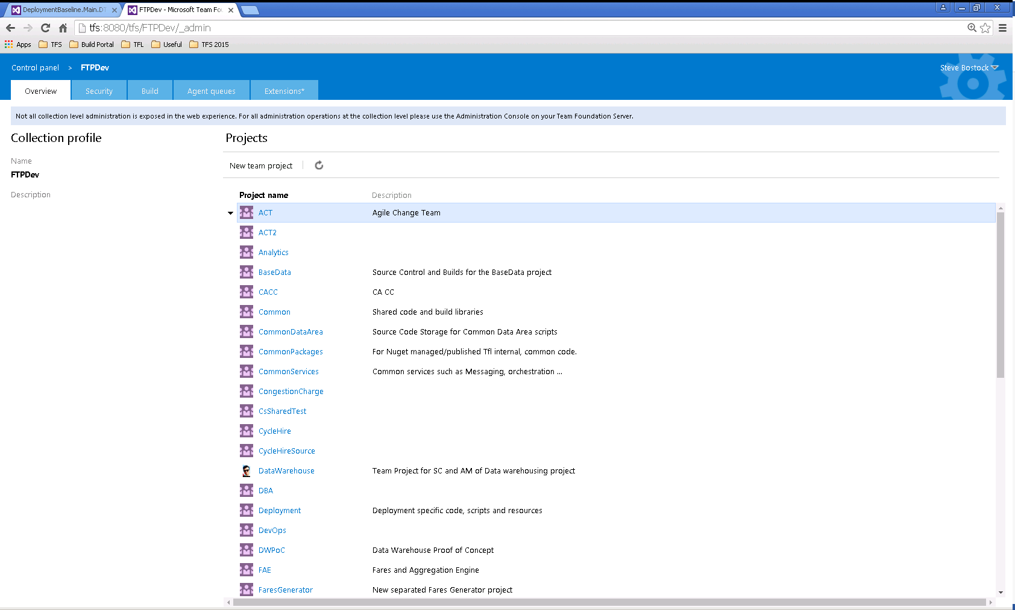

From here click on the Download Agents link  
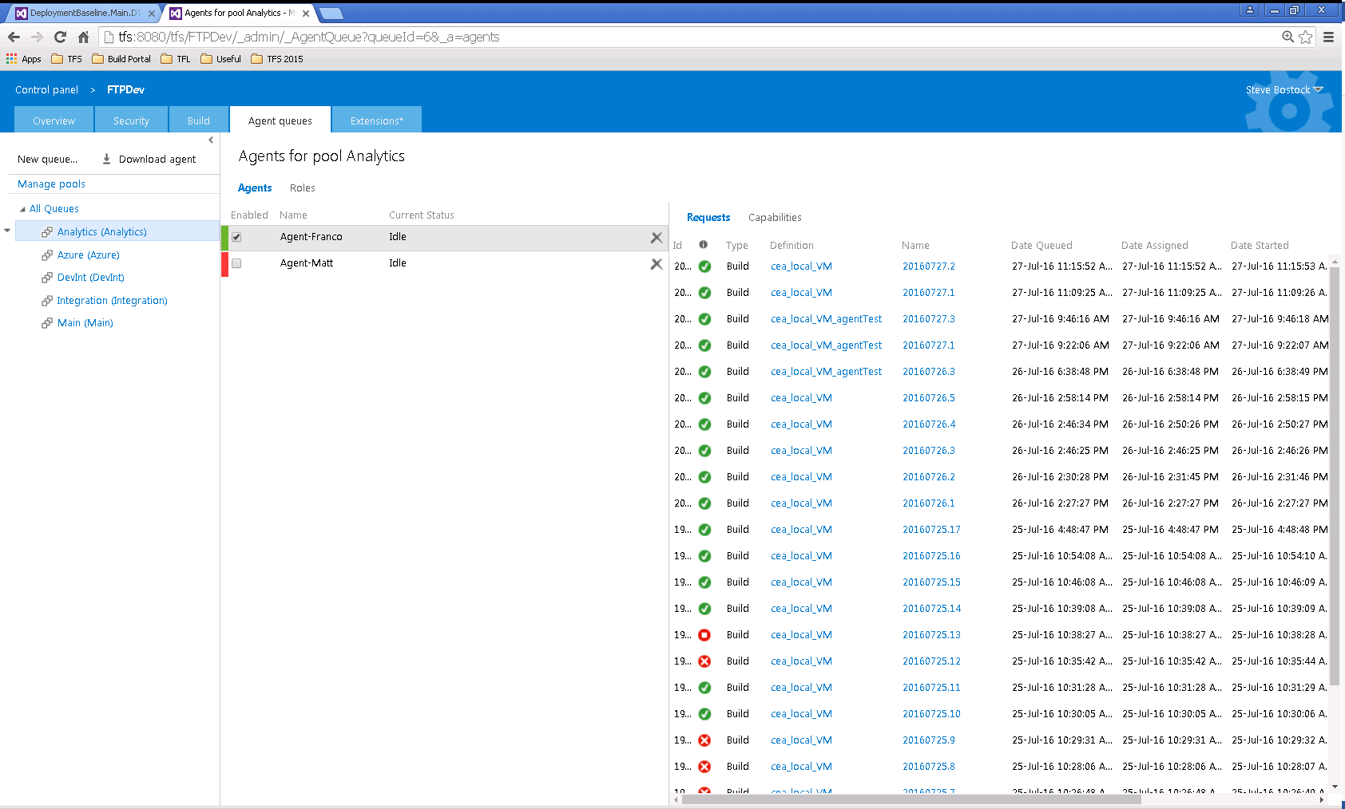

Copy the zip file into the folder you had created earlier.  
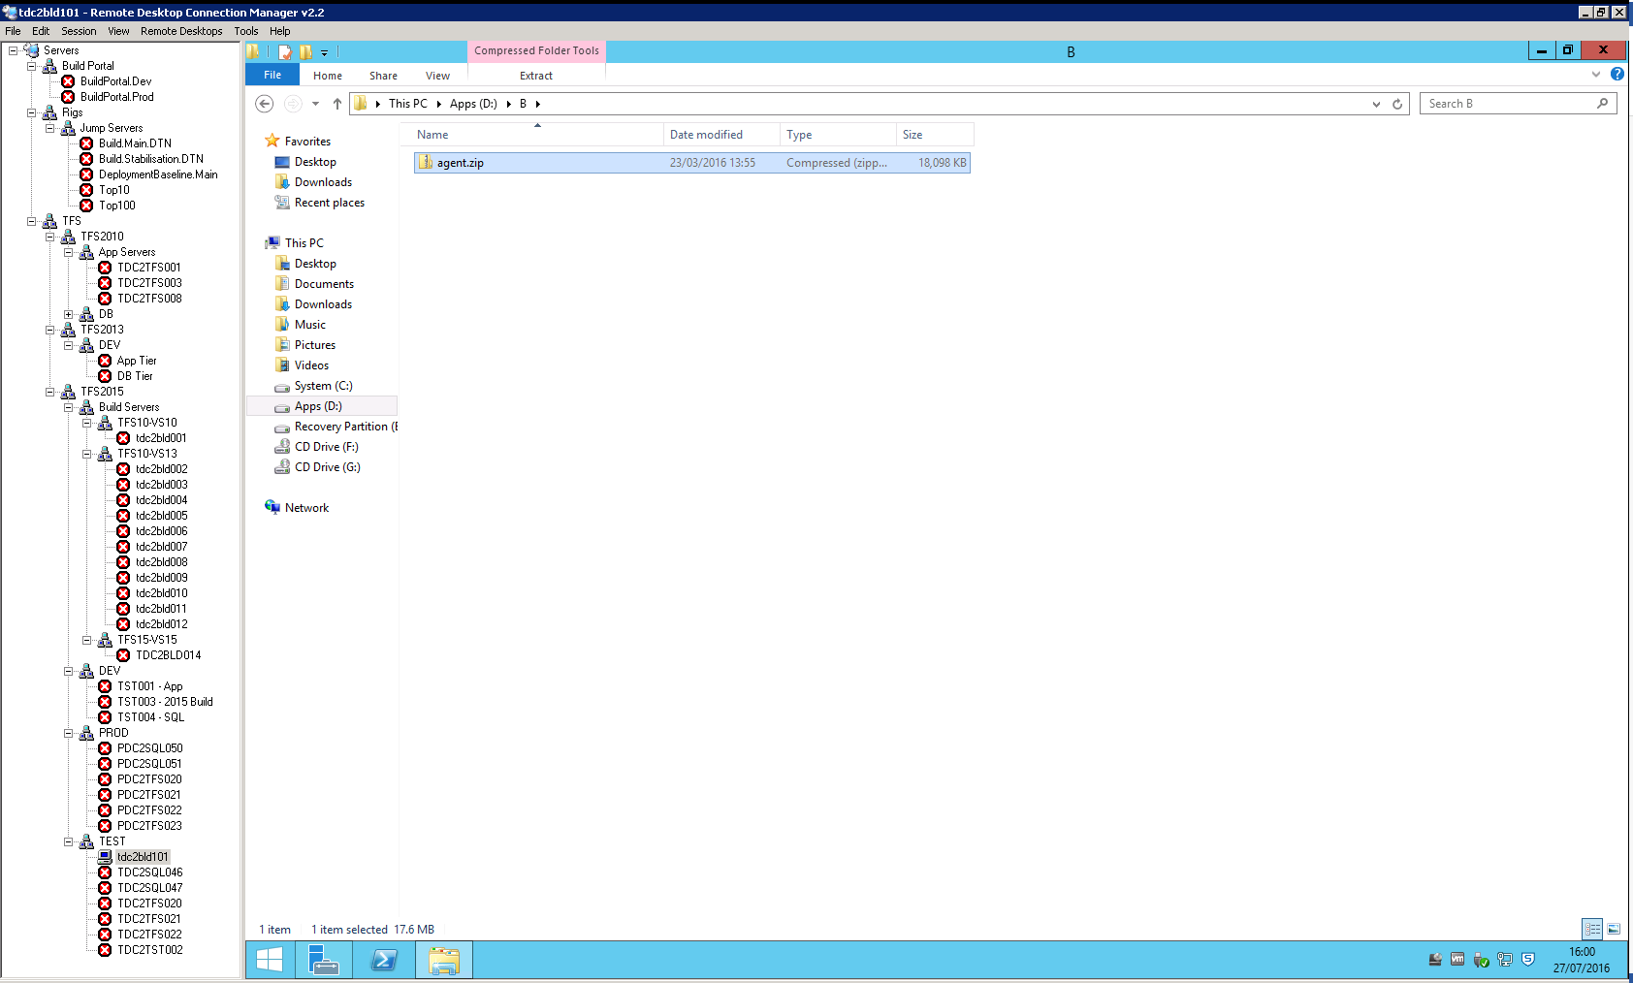

Extract the zip four times into folder called: **01, 02, 03** and **04**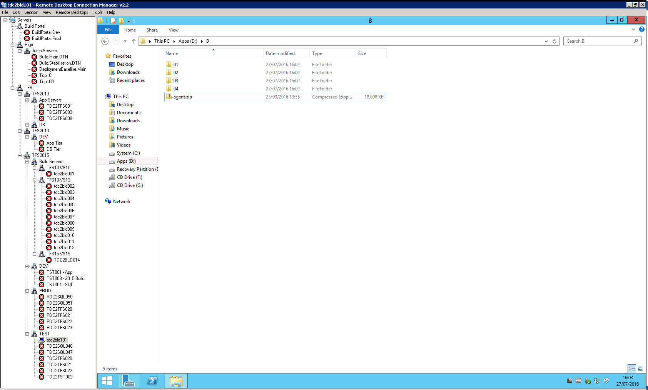

# Setting up the Agent

Go into the folder created from extracting the agent.zip, you will see a ConfigureAgent.cmd file. If you see other files the agent may have been previously configured, running this cmd file will update the agent settings to our needs.

Double Click on cmd and provide answer to powershell window when prompted like in the Image below:

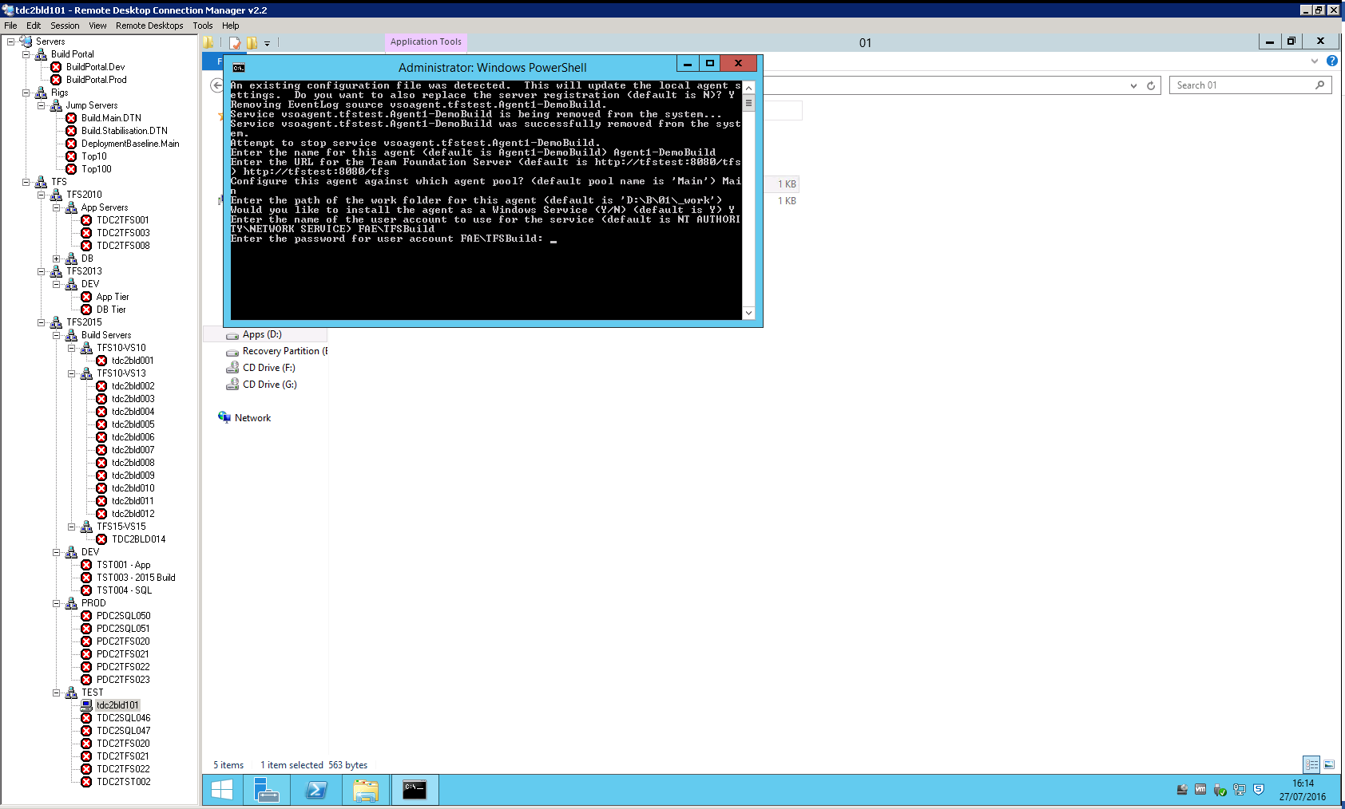

We are currently using the following setup

* Agent Name: Agent X – Machine Name
* TFS URL: <http://tfs:8080/tfs>
* Pool Name: The name of your pool. We should be mainly using Main
* Work Folder: Leave this as default
* Install as Service: Yes
* Service Account Name: FAE\TFSBuild
* Password: CEBuild know this.

## Verify SQLCMD tools are working

1. Open a command prompt and enter “sqlcmd /?”
2. You should see the following if the tools have been set up correctly

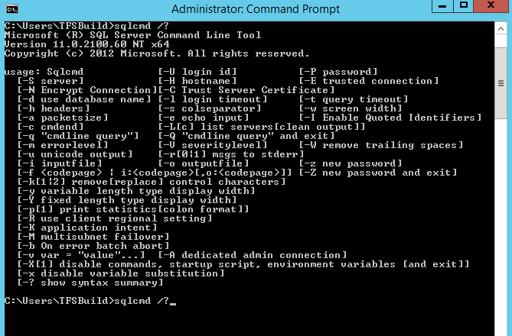

1. If the command does not resolve you will get an error. It is worth checking that the PATH variable includes the file path to the sqlcmd binaries.

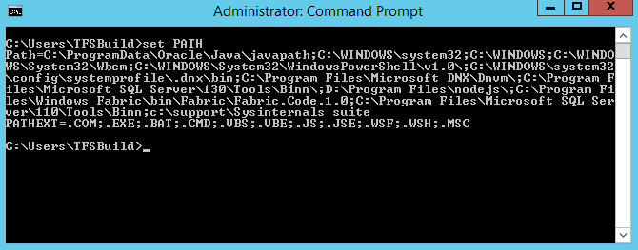

C:\Program Files\Microsoft SQL Server\Tools\Binn should be included in the path. If not, verify the tools have been installed at this location and add this to the PATH environment variable.

## Credentials Setup

1. Open PowerShell as Admin
2. Run command

Enable-WSManCredSSP -Role Client -DelegateComputer 10.107.*

1. Accept Any prompt and warnings
2. You should get the following output

PS C:\Windows\system32> Enable-WSManCredSSP -Role Client -DelegateComputer 10.10.7.*

cfg : http://schemas.microsoft.com/wbem/wsman/1/config/client/auth

lang : en-US

Basic : true

Digest : true

Kerberos : true

Negotiate : true

Certificate : true

CredSSP : true

1. Open Start -> Run
2. Enter gpedit.msc and click OK
3. 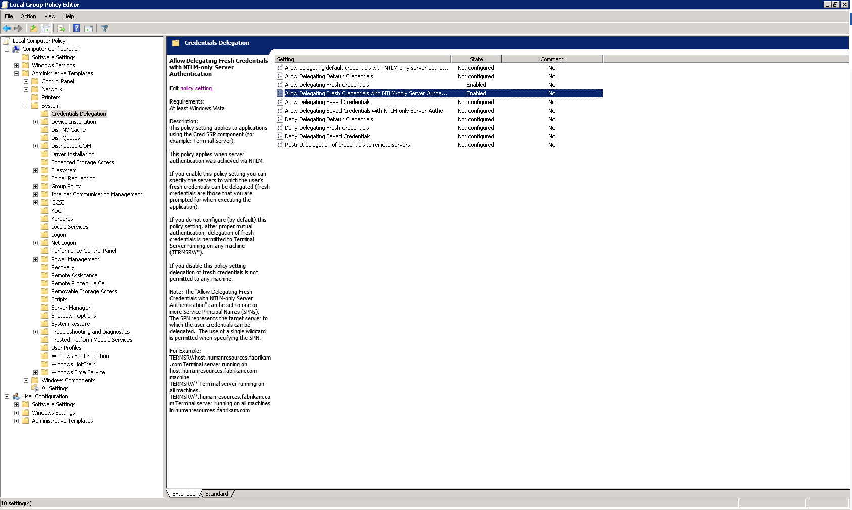Expand Local Computer Policy -> Computer Configuration -> Adminstrative Templates -> System -> Credentials Delegation
4. Open “Allow Delegating Fresh Credentials with NTLM-Only Server Authentication
5. Click Enable
6. Click Show next to Add Servers to the list  
   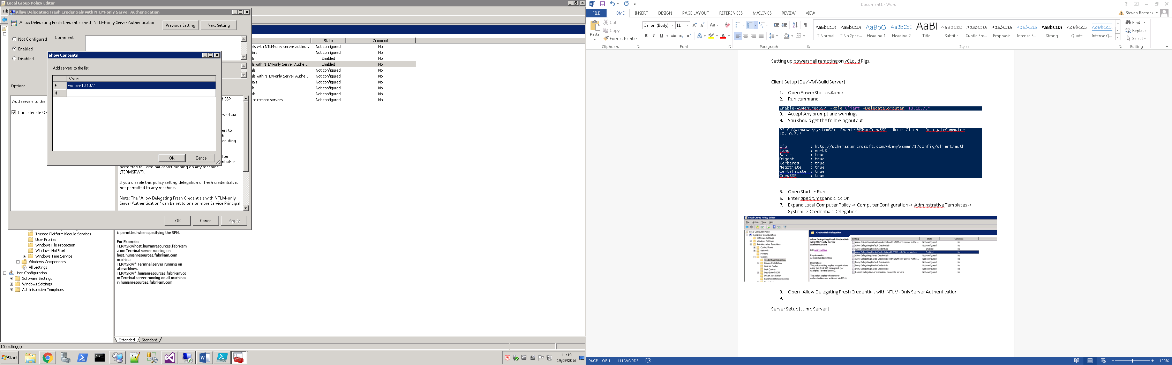
7. Add the value “WSMAN/10.107.*
8. Click OK on both windows

Once you have entered all your information, the cmd file create your windows services and register your agent with TFS. You will then be good to start using this with builds.